
MNG 180-12
12V180AH
MNG Series GEL Battery
VRLA Battery

MNG Series-- Storage-type Gelled Battery
- completely sealed and maintenance-free, low self-discharge
- 100% precise quality testing, stable quality and high reliable performance
- Unique grid alloy formula, Gelled electrolyte formula and updated manufacturing technique
- Floating & standby use:up to 12 years
- Cycle use 1: More than 350 cycles at 100% DOD
- Cycle use2: More than 1800cycles at 30% DOD
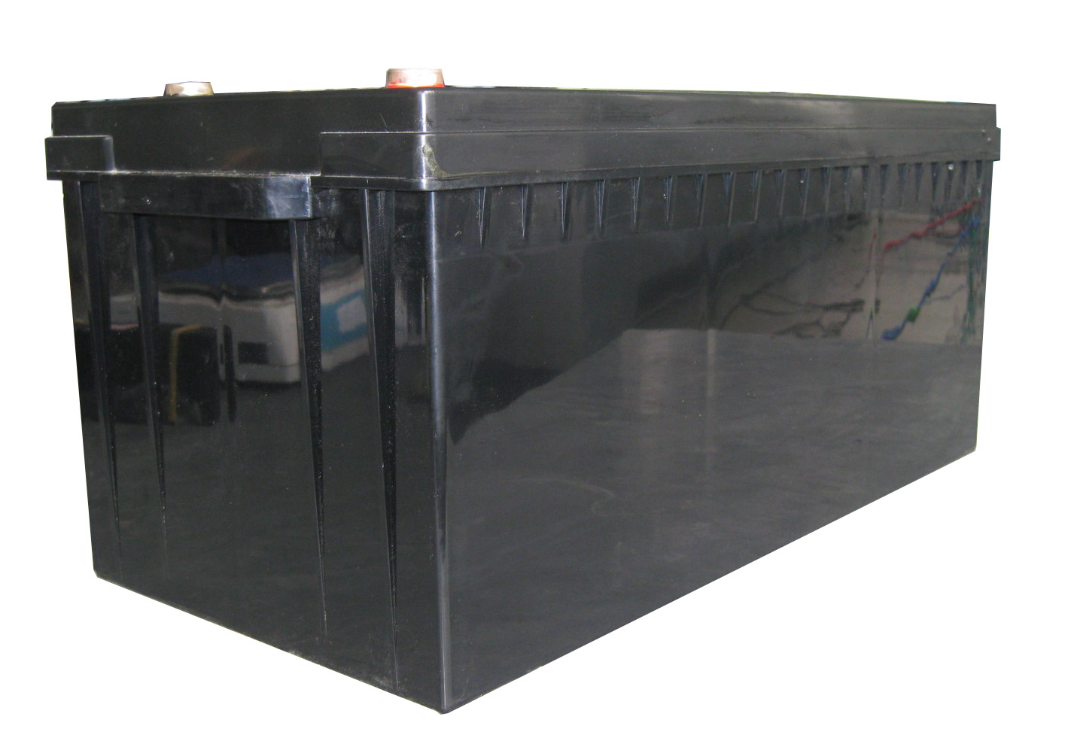

Application:
- Telecommunications
- UPS/EPS
- DC PowerSupply
- Solar system
- Wind Power System
- Auto Control Sytem

Construction:
- Component ......Raw material
- Positive ........Lead dioxide
- Negative ........Lead
- Container ........ABS
- Cover ........ABS
- Sealant ........Epoxy
- Safety valve .... Rubber
- Terminal ........Copper/Pb
- Separator ........Fiber glass
- Electrolyte ....... Gelled acid
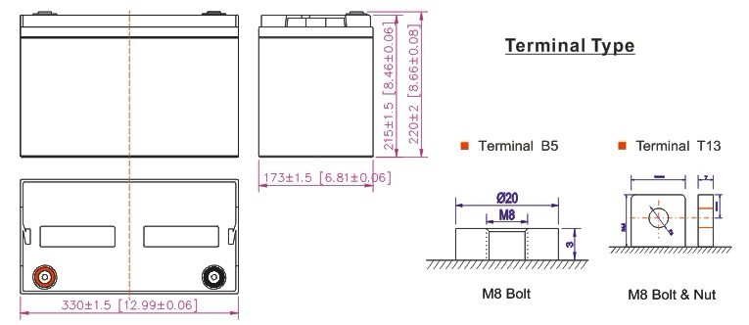
B5 Terminal

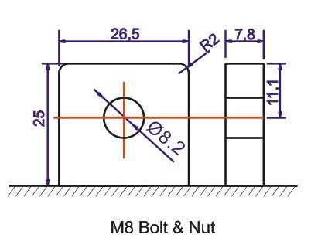
T16 Terminal

Speification:
Battery Model | MM 180-12 12V180AH
Designed Floating Life | Up to 12 Years
Capacity (25℃) | 20HR(9.0A,10.8V) | 10HR(18A,10.8V) | 5HR(31.5A,10.8V) | 1HR(108A,10.5V)
Capacity (25℃) | 180AH | 173AH | 153AH | 108AH
Dimensions | Length | Width | Height | Total Height
Dimensions | 523mm (20.59inch) | 240mm (9.45inch) | 220mm (8.66inch) | 245mm (9.64inch)
Approx. Weight | 55.50Kg (123 lbs)
Internal Resistance | Full charged at 25℃:≤3.0mΩ
Self Discharge | 2% of capacity declined per month at (25℃)
Capacity Affected  by Temp.(20HR) | 40℃ | 25℃ | 0℃ | -15℃
Capacity Affected  by Temp.(20HR) | 102% | 100% | 85% | 65%
Charge Voltage(25℃) | Cycle use |  | Float use
Charge Voltage(25℃) | 14.4-14.6V(-30mV/℃), max. Current:60A |  | 13.6-13.8V (-20mV/℃)

VRLA Battery
MNG 180-12
12V180AH
Terminal Voltage (V) and Discharge Time
Capacity Retention Characteristic

Battery Vlotage and Charge Time for Standby Use
Battery Vlotage and Charge Time for Cycle Use

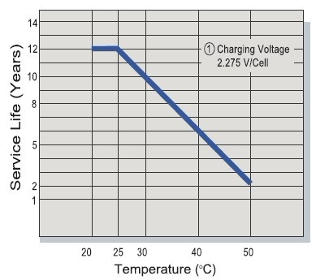
Tickle(or Float) Service Life

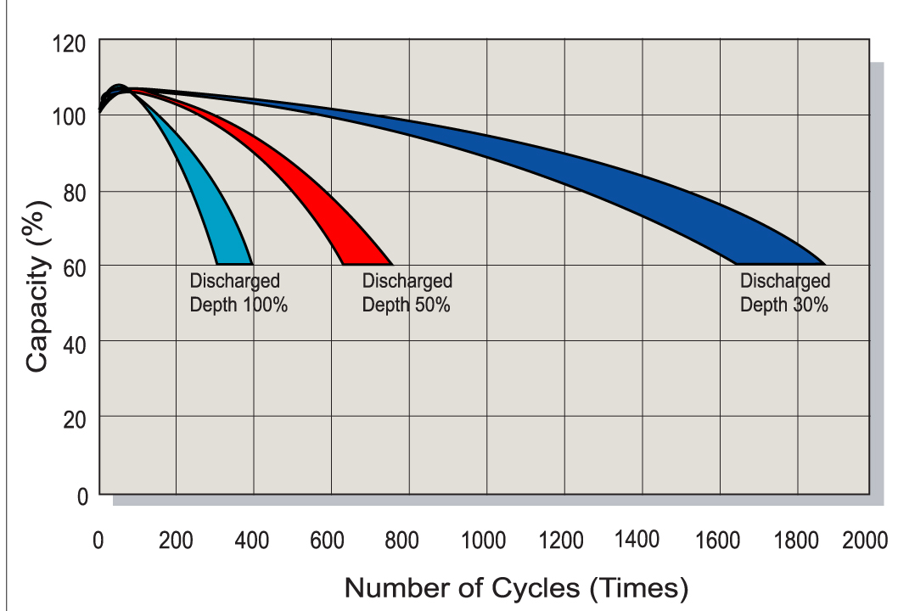

Cycle Service Life

Battery Vlotage and Charge Time for Cycle Use

Constant Current Discharge(CC,Unit:A) at 25℃(77℉)
F.V/Time | 5Min | 10Min | 15Min | 30Min | 1Hr | 2Hr | 3Hr | 4Hr | 5Hr | 8Hr | 10Hr | 20Hr
9.60V | 576 | 378 | 306 | 205 | 108 | 63 | 46.3 | 36 | 30.6 | 21.1 | 18.9 | 10.1
10.2V | 558 | 342 | 288 | 196 | 101 | 60 | 45 | 35 | 29 | 20.5 | 18.5 | 9.9
10.5V | 540 | 306 | 252 | 184 | 98 | 58.5 | 44 | 34.5 | 28.5 | 20.3 | 18.2 | 9.7
10.8V | 518 | 288 | 234 | 169 | 94.5 | 57 | 42.5 | 34 | 28 | 19.8 | 18 | 9.5
11.1V | 503 | 270 | 216 | 151 | 92 | 55.5 | 41.4 | 33 | 27.4 | 19.3 | 17.1 | 9
Constant Power Discharge (CP,Unit:W) at 25℃(77℉)
F.V/Time | 5Min | 10Min | 15Min | 30Min | 1Hr | 2Hr | 3Hr | 4Hr | 5Hr | 8Hr | 10Hr | 20Hr
9.60V | 5932 | 3893 | 3151 | 2152 | 1134 | 661 | 486 | 378 | 321 | 221 | 198 | 106
10.2V | 5747 | 3522 | 2966 | 2058 | 1060 | 630 | 471 | 367 | 304 | 215 | 194 | 104
10.5V | 55624 | 3151 | 2595 | 1932 | 1029 | 614 | 462 | 362 | 299 | 213 | 191 | 101
10.8V | 5335 | 2966 | 2410 | 1774 | 992 | 598 | 446 | 357 | 294 | 207 | 189 | 99.5
11.1V | 5180 | 2781 | 2224 | 1585 | 966 | 582 | 434 | 346 | 287 | 202 | 179 | 94

