
NP 33-12
12V33AH

VRLA Battery
VRLA Battery
- completely sealed and maintenance-free, low self-discharge
- 100% precise quality testing, stable quality and high reliable performance
- Unique grid alloy formula and updated manufacturing technique
- Floating & standby use:up to 5 years
- Cycle use 1: More than 280 cycles at 100% DOD
- Cycle use2: More than 1400cycles at 30% DOD

Application:
- Telecommunications
- UPS/EPS
- DC Power Supply
- Solar system
- Wind Power System
- Auto Control System

Construction:
- Component ......Raw material
- Positive ........Lead dioxide
- Negative ........Lead
- Container ........ABS
- Cover ........ABS
- Sealant ........Epoxy
- Safety valve ....Rubber
- Terminal ........Copper/Pb
- Separator ........Fiber glass
- Electrolyte .......Sulfuric acid
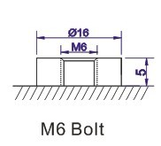
B4 Terminal

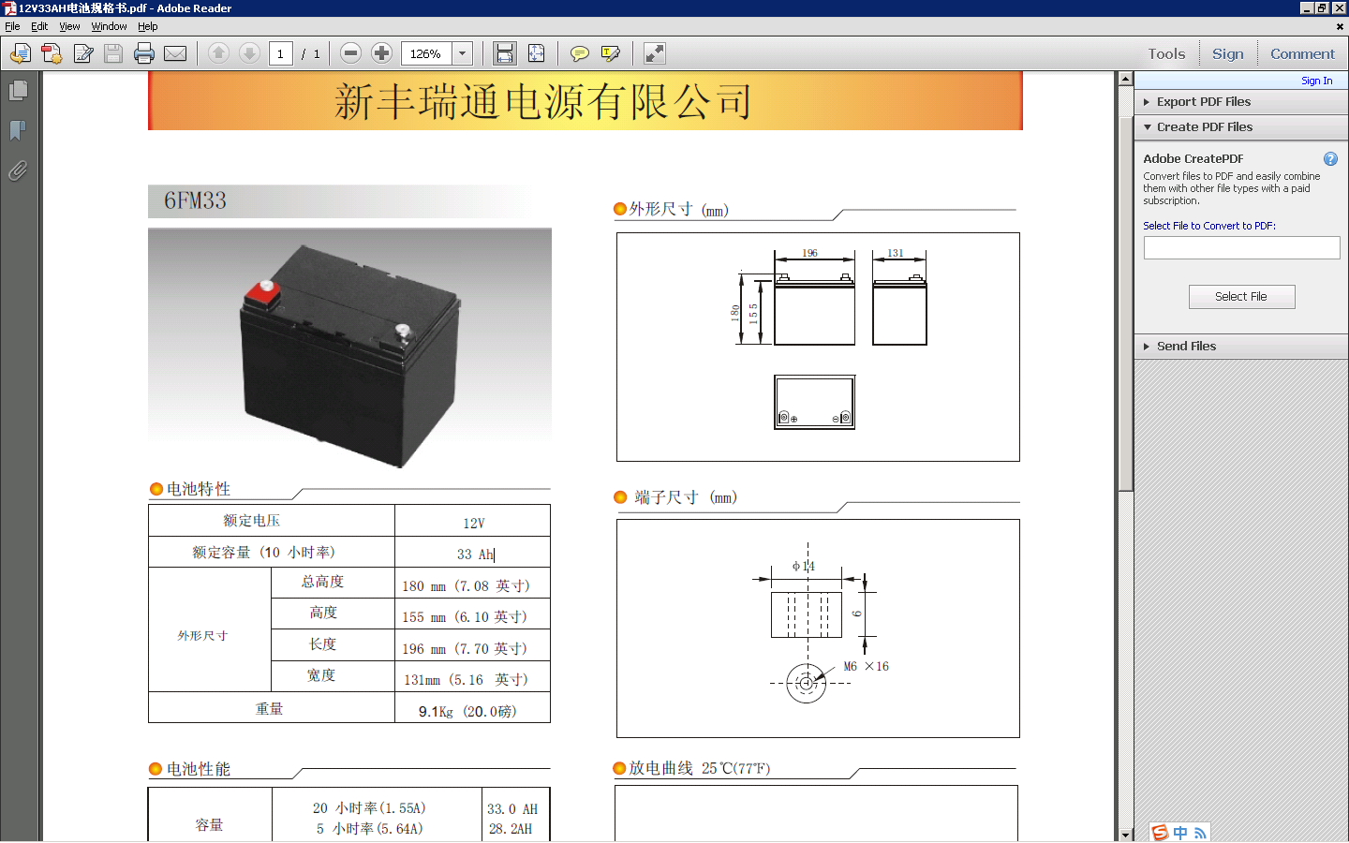
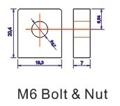
T11 Terminal
Specification:
Battery Model | NP 33-12 12V33AH
Designer Floating Life | Up to 5 Years
Capacity (25℃) | 20HR(1.66A,10.5V) | 10HR(3.30A,10.5V) | 5HR(5.61A,10.5V) | 1HR(18.2A,10.5V)
Capacity (25℃) | 33.20AH | 33.00AH | 28.05AH | 18.20AH
Dimensions | Length | Width | Height | Total Height
Dimensions | 196mm (7.72inch) | 130mm (5.1inch) | 155mm (6.10inch) | 180mm (6.69inch)
Approx. Weight | 10.80Kg (23.81 lbs)±5%
Internal Resistance | Full charged at 25℃:≤9.0mΩ
Self Discharge | 2% of capacity declined per month at (25℃)
Capacity Affected  by Temp.(20HR) | 40℃ | 25℃ | 0℃ | -15℃
Capacity Affected  by Temp.(20HR) | 102% | 100% | 85% | 65%
Charge Voltage(25℃) | Cycle use |  | Float use
Charge Voltage(25℃) | 14.40-15.00V(-30mV/℃), max. Current:8.25A |  | 13.50-13.80V (-20mV/℃)
12V100AH
VRLA Battery
NP 33-12
12V33AH
Terminal Voltage (V) and Discharge Time
Capacity Retention Characteristic

Battery Vlotage and Charge Time for Standby Use
Battery Vlotage and Charge Time for Cycle Use

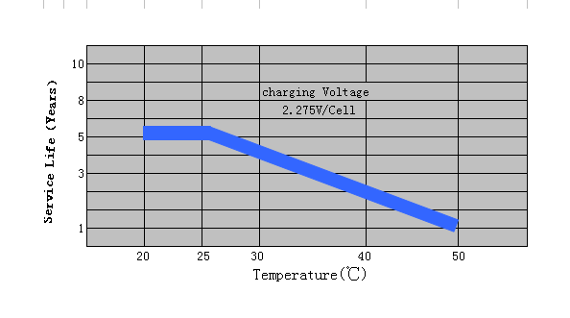
Tickle(or Float) Service Life

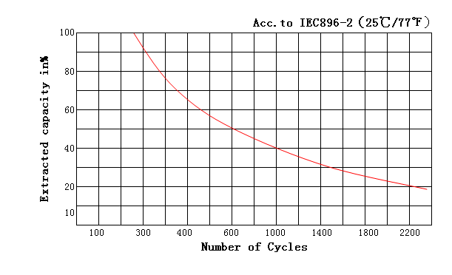

Cycle Service Life

Battery Vlotage and Charge Time for Cycle Use

Constant Current Discharge(CC,Unit:A) at 25℃(77℉)
F.V/Time | 5Min | 10Min | 15Min | 30Min | 1Hr | 2Hr | 3Hr | 4Hr | 5Hr | 6Hr | 10Hr | 20Hr
1.85V/Cell | 73.8 | 54.3 | 47.2 | 28.5 | 16.8 | 9.9 | 7.4 | 6.21 | 5.11 | 4.70 | 3.13 | 1.61
1.80V/Cell | 76.6 | 56.4 | 49.0 | 29.5 | 17.5 | 10.3 | 7.7 | 6.46 | 5.32 | 4.90 | 3.27 | 1.63
1.75V/Cell | 84.3 | 59.2 | 51.4 | 30.7 | 18.2 | 10.6 | 7.9 | 6.53 | 5.38 | 4.95 | 3.30 | 1.66
1.70V/Cell | 94.2 | 62.1 | 53.9 | 32.2 | 18.5 | 10.8 | 8.1 | 6.59 | 5.43 | 5.00 | 3.33 | 1.71
1.67V/Cell | 104.2 | 64.9 | 56.3 | 33.1 | 19.2 | 11.1 | 8.3 | 6.66 | 5.48 | 5.04 | 3.36 | 1.73
Constant Power Discharge (CP,Unit:W) at 25℃(77℉)
F.V/Time | 5Min | 10Min | 15Min | 30Min | 1Hr | 2Hr | 3Hr | 4Hr | 5Hr | 6Hr | 10Hr | 20Hr
1.85V/Cell | 140.2 | 103.3 | 89.6 | 54.1 | 31.9 | 18.8 | 14.0 | 11.79 | 9.71 | 8.93 | 5.96 | 3.06
1.80V/Cell | 145.5 | 107.2 | 93.1 | 56.1 | 33.2 | 19.5 | 14.6 | 12.28 | 10.11 | 9.31 | 6.20 | 3.19
1.75V/Cell | 160.1 | 112.6 | 97.7 | 58.4 | 34.5 | 20.1 | 15.0 | 12.41 | 10.21 | 9.40 | 6.27 | 3.23
1.70V/Cell | 179.0 | 117.9 | 102.4 | 61.2 | 35.2 | 20.5 | 15.3 | 12.53 | 10.31 | 9.49 | 6.33 | 3.26
1.67V/Cell | 197.9 | 123.3 | 107.0 | 62.9 | 36.5 | 21.1 | 15.7 | 12.65 | 10.42 | 9.58 | 6.39 | 3.29

